INSPECTING DATA
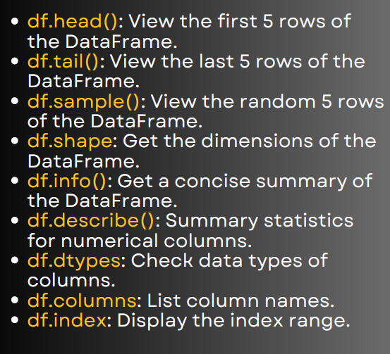

Inspecting Data in Pandas
import pandas as pd
# Sample DataFrame
data = {
"Name": ["Ravi", "Sita", "Amit", "Priya", "Kiran", "Anita"],
"Age": [25, 30, 22, 28, 35, 27],
"Salary": [50000, 60000, 45000, 70000, 80000, 52000],
"Department": ["HR", "IT", "Finance", "IT", "HR", "Finance"]
}
df = pd.DataFrame(data)

1. df.head() → First 5 rows
print(df.head())
Useful for quickly checking the start of the dataset.

2. df.tail() → Last 5 rows
print(df.tail())
Useful for verifying end rows (especially after appending data).

3. df.sample() → Random 5 rows
print(df.sample(3)) # Example: pick 3 random rows
Good for quickly checking random records in big datasets.

4. df.shape → Dimensions (rows, columns)
print(df.shape)
Output: (6, 4) → 6 rows, 4 columns

5. df.info() → Summary (column names, types, non-null counts)
print(df.info())
Helps check null values & datatypes.

6. df.describe() → Summary statistics
print(df.describe())
Gives count, mean, std, min, max, etc. (only for numeric columns).

7. df.dtypes → Data types of each column
print(df.dtypes)
Example Output:
Name object
Age int64
Salary int64
Department object
dtype: object
8. df.columns → List column names
print(df.columns)
Output: Index(['Name', 'Age', 'Salary', 'Department'], dtype='object')

9. df.index → Index range
print(df.index)
Output: RangeIndex(start=0, stop=6, step=1)

